Tester | Date | data | photo | What should happen | What did happen
I open the website and it didn’t crash | 10/10/25 | N/A | 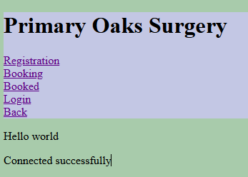  Main page | The website should load and the connection to the data base was successfully | It did that
Know I will try to open the Registration page which should by load fast | 10/10/25 | N/A | 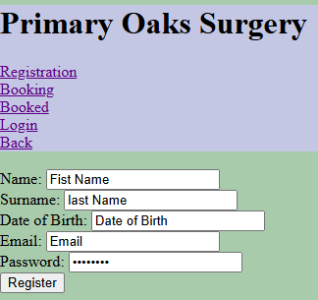  Registration page | The website should load | It did load the page fast.
Know I’m going to input the data which is required | 10/10/25 | First name  last name  birthday  email  password | 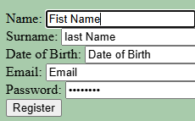  Input the data | The the data I enter is revised to the data base was correct and didn’t sent an error tag | It didn’t crash and sent a error tag
 | 10/10/25
 |  |  | It works

